SHORT DOCUMENTATION AND TESTING

INTRODUCTION

React JS was used for the front end or view of the system. It is open source and was developed by Facebook Inc to allow developers to create reusable user interface components, create large web applications and mobile applications without the need to reload pages manually. The system uses third party libraries and APIs and frameworks, the first and most used is Axios which is responsible for creating a connection between the backend and the frontend of the system by using http promises to fetch and save data or cancel requests. The second one is bootstrap 4 framework and react bootstrap to create responsive, mobile first web templates that are uniformly styled. React-router-dom was not used to create navigation and to link pages. Normal html link was used to create one interconnected system. The system can work on all electronic devices, it will automatically resize according to screen size making it simple and easy for different people using different devices to access and use the system.

1.Postman

Postman was used to read and test the api from newyork times, after reading the file it was then confirmed that the key works with the api and the structure of the json file.

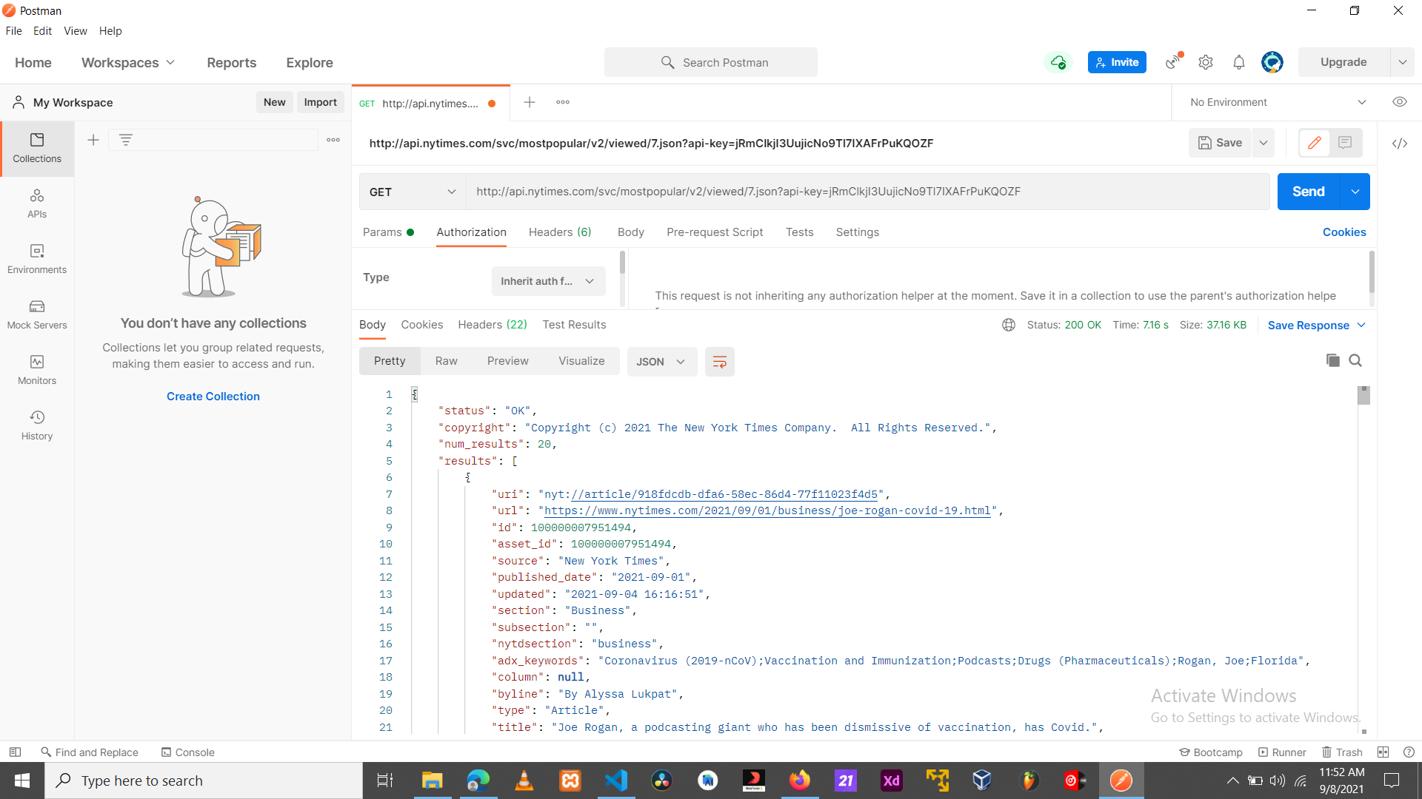

2.Short testing using Jest to create coverage report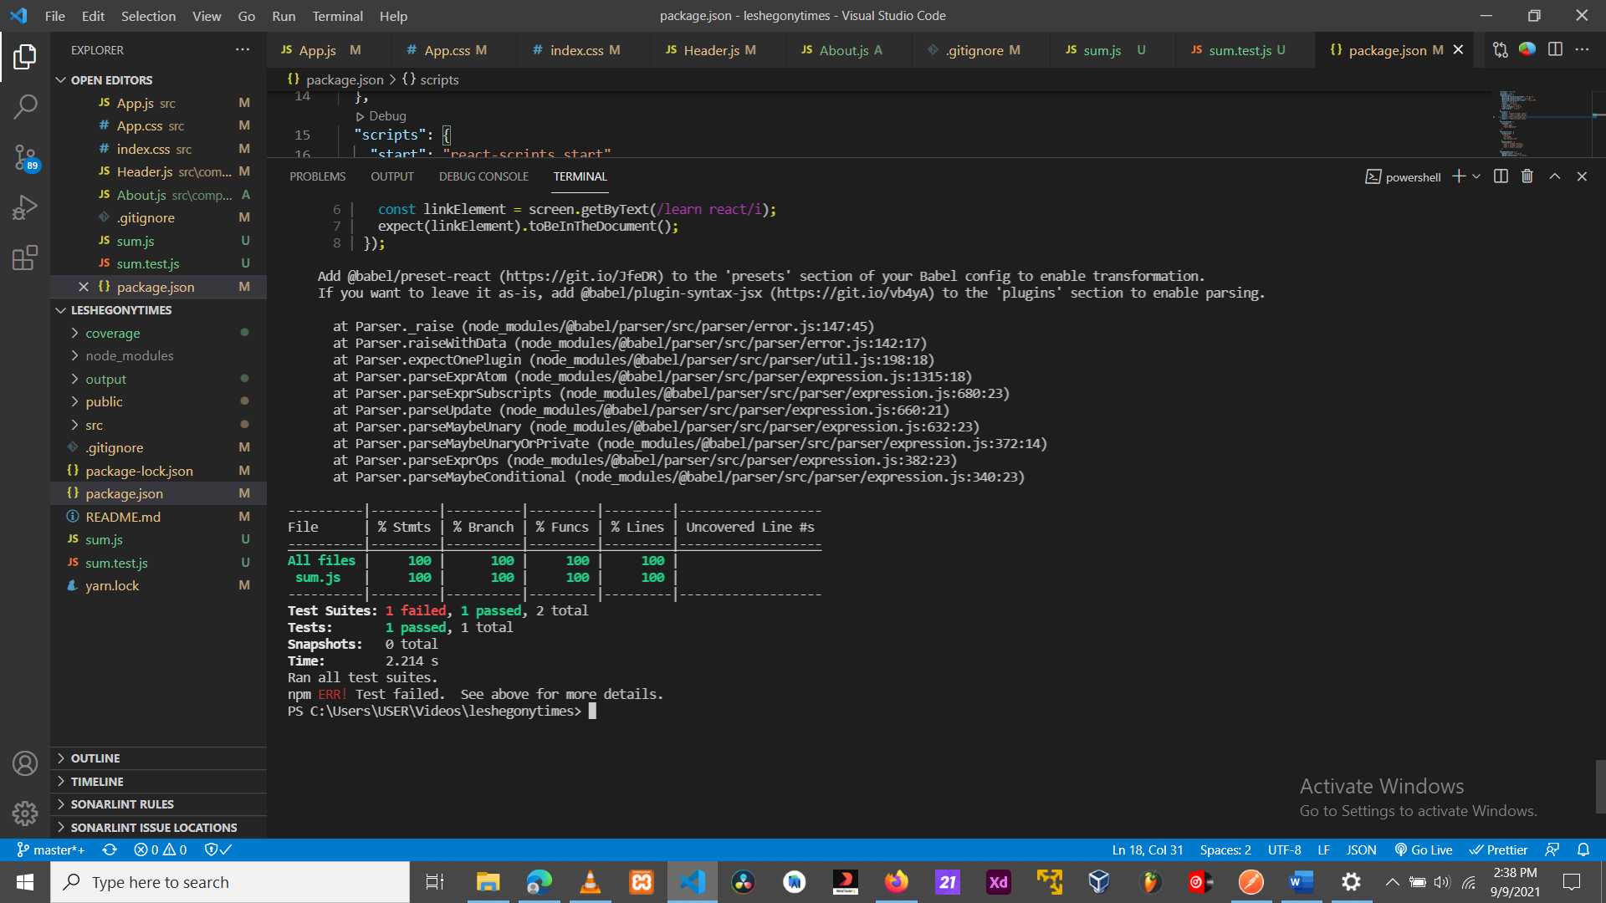

3. (a typical master/detail app) Failed: The web app is able to read all articles from the New York times Api and display them in an easy and friendly readable manner, users can tap and expand to view mor details about he article. The problem is that all the articles use on key which means that when one is tapped all of them expand and close when tapped again.